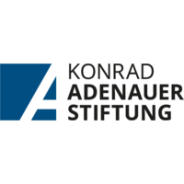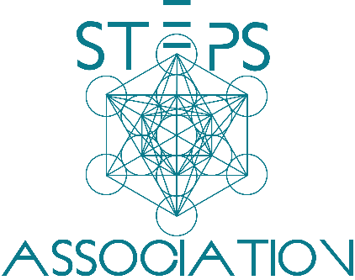

**ZOON POLITIKON PROGRAM**

February, 14th - 19th 2022

**KAS Office**

Monday, february 14, KAS office

16.00h - 17.15h Introduction - Should we care about politics?, Amra Pandžo, Adnan Hasanbegović

17.30h – 19.00h Political Philosophy (Discussion), Uma Đurić

19 h – 19.30 h Dinner

tuesday, february 15, kas office

16.00h - 16.15h Sven Petke, Head of Office Konrad Adenauer Foundation

16.15h - 17.15h Plato's State, Machiavelli's Prince – Imaginary Political Systems and Political Awareness , Prof. Dr. Nedžma Džananović Miraščija

17.30h – 19.00h Political Compass Quiz, Uma Đurić

19 h – 19.30 h Dinner

wednesday, february 16, kas office

16.00h - 18.00h Creating imaginary political system inspired by Plato's Republic (Workshop), Uma Đurić

18.10h - 19.00h Compass Discussion – Confronting Opposite Political Views (Workshop), Uma Đurić

19 h – 19.30 h Dinner

thursday, february 17 2021, kas office

16.00h - 17.30h Practical Politics – Lessons from conflict transformation of political actors and veterans, Adnan Hasanbegović

17.40h - 19.00h Barometer Exercise, Amra Pandžo

19 h – 19.30 h Dinner

friday, february 18, kas office

16.00h - 17.30h Grassroot Change Making – Find the Problem in Your Community, Amra Pandžo (Workshop)

17.40h - 19.00h Solution Mapping – What can we do to make a change? Amra Pandžo

19 h – 19.30 h Dinner

saturday, february 19, kas office

16.00h - 17.30h Creating my personal Political Narrative, Amra Pandžo (Workshop)

17.40h - 19.00h How My Own Political Narrative Can Shape Solutions for Political Crises? Amra Pandžo

19 h – 19.30 h Dinner