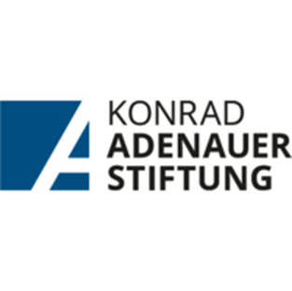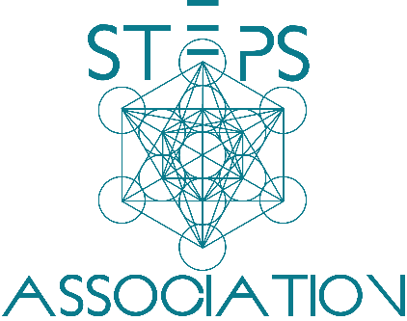

The Politics of the Other

**August 3rd 2024 – August 4th 2024**

Place: Konrad Adenauer Foundation

Program Overview

**The Politics of the Other** is a comprehensive two-day workshop that tackles the complexities of perceiving and engaging with the "Other" in the context of conflict resolution. This program integrates perspectives from peacebuilding, political science, and theatre practices to offer participants an understanding and practical tools for addressing conflicts rooted in otherness.

During the two days of the program, participants will explore the theoretical foundations of the concept of the Other, examining how this construct shapes political identities, social dynamics, and conflict situations.

Participants will engage in interactive sessions that combine academic insights with experiential learning techniques. Theatre practices, including role-playing and puppetry, will be used to foster empathy and understanding, allowing participants to identify with the Other and view conflicts from multiple perspectives. These activities aim to break down barriers and encourage more compassionate approaches to conflict resolution.

By the end of the program, participants will have developed an understanding of the mechanisms of othering and acquired practical skills to transform conflicts. They will be better equipped to promote reconciliation in their communities with a holistic approach that acknowledges the complexities of human interactions.

Lecturers and Trainers

**Amra Pandžo** is a lecturer and trainer in the field of peacebuilding and conflict transformation. She has worked in B&H, Kosovo, Ukraine, Afghanistan and the United States, teaching peace and reconciliation at all levels of society. Amra received her doctorate at the Faculty of Political Sciences at the University of Sarajevo at the Department for Security and Peace Studies. She has lectured in the Center for Interdisciplinary Postgraduate Studies (CIPS) Religious Studies program in the subjects Violence and Solving Conflict and has been a guest lecturer at the University of Zurich. In a TPO Foundation poll, she was voted as one of the 11 most influential women who built peace in post-war B&H.

**Nerzuk Ćurak** is a professor at the Faculty of Political Sciences at the University of Sarajevo, a journalist, essayist, and publicist, a public intellectual, and a peace activist. His scientific interests focus on geopolitics, geophilosophy, political philosophy, international relations, international security, polemology, conflict management, peace theory, democracy and security challenges, ethnopolitics, and public policies.

**Benjamin Konjicija** is the founder and an active member of the independent theatre association Magični Teatar. He has directed, wrote and co-wrote a number of plays within the association, including "Šta su skrivili Ivica i Marica? // Hansel and Grettel: What Did They Do Wrong?" (2019), "Lan Guinée" (2023), "Hodočašće // Pilgrimage" (2024), and "Plavobradi // Bluebeard" (2024). In addition to this, he also conducts workshops on the methods of Magični Teatar.

As a dramaturge, he has worked on several productions, including "Bordel Eden // Brothel Eden" (2022) and "Idiot // The Idiot '' (2023) at the Sarajevo National Theater. He has also served as an assistant director and performer in the play "Nije to to // That's Not It" (2020) at the Sarajevo War Theater. In 2022, he was an apprentice at The Bread and Puppet Theater in Glover, USA.

**Uma Đurić** is a performance artist, activist and researcher. She has held more than 100 trainings and interactive lectures for youth across Western Balkans through different projects in the field of performance art, activism and media literacy. Đurić is the Program Coordinator at Small Steps and artist at Magični Teatar, as well as advisor for various organizations and independent artists (CIM, YIHR, Foundation of Local Democracy, Youth for Peace, Happy End Story Productions and others). Apart from her work in fields of culture and education, she is also a BOLD Fellow and the director of Shia & Kark, a consulting company for event organization and teambuilding.

**SATURDAY, AUGUST 3RD 2024**

**12:00h - 12:15h: Registration and Welcome**

* Participants arrive and sign in.
* Brief introduction by the lecturers.

**12:15h - 13:15h: Understanding Conflict - Nerzuk Ćurak**

* Introduction to Conflict: Definition and types of conflict.
* Causes of Conflict: Common triggers and underlying issues.
* Personal Conflict Styles: Self-assessment and discussion of different conflict styles (e.g., avoidant, confrontational, cooperative).

**13:15h - 13:30h: Break**

**13:30h - 14:30h: The Other in Conflict - Nerzuk Ćurak**

* Concept of 'The Other': Understanding how we perceive and relate to others in conflict situations.
* Empathy and Perspective-Taking: Exercises and discussions on seeing from another's viewpoint.
* Becoming the Other - Discussion

**14:30h - 15:30h: Conflict Resolution - Amra Pandžo**

* Effective Communication: Active listening, assertive communication, and I-statements.
* Negotiation and Mediation: Strategies for finding mutually acceptable solutions.
* Problem-Solving: Collaborative approaches to resolving conflicts.

**14:30h - 15:15h: Lunch Break**

**15:15h - 16:30h: Practical Application - Amra Pandžo**

* Role-Playing Exercise: Participants practice conflict resolution techniques in pairs or small groups.
* Feedback and Discussion: Group feedback on role-playing exercise

**SUNDAY, AUGUST 4TH 2024**

**12:00h - 12:15h: Introduction**

* **Welcome and Icebreakers**
  + Introduction of facilitators and participants.
  + Quick icebreaker activity to create a comfortable atmosphere.
* **Context Setting**
  + Introduction of the concept of objectification and its connection to acts of violence.
  + Brief overview of the workshop objectives.

**12:15h - 12:45h: Exploration of the Puppet as an Object - Benjamin Konjicija**

* **Introduction to the Puppet**
  + Present the human-sized, faceless puppet.
  + Discuss initial impressions and reactions to the puppet as an object.
* **Guided Exploration**
  + Participants engage in a hands-on exploration of the puppet.
  + Encourage participants to touch, move, and examine the puppet to understand its physical properties.

**12:45h - 13:00h: Discussion and Reflection - Uma Đurić**

* **Group Discussion on the Experience**
  + Discuss the experience of interacting with the puppet as an object.
  + Reflect on feelings of detachment or objectification during the interaction.

**13:00h - 14:00h: Animating the Puppet: Transformation from Object to Subject - Benjamin Konjicija**

* **Basics of Puppetry**
  + Introduction to fundamental puppetry techniques.
  + Demonstration by facilitators on how to manipulate the puppet.
* **Collaborative Animation Exercise**
  + Split participants into small groups.
  + Each group practices animating the puppet, focusing on bringing it to life and exploring different roles.
  + Facilitators provide guidance and feedback.
* **Performance and Feedback**
  + Each group presents a short skit demonstrating the puppet's transformation.
  + Group feedback and discussion on the puppet's journey from object to animate being.

**14:00h - 14:45h: Empathy and the Other: Deepening the Experience - Uma Đurić**

* **Role Reversal Exercise**
  + Participants take turns being both the puppeteer and the puppet.
  + Focus on experiencing both perspectives and developing empathy.
* **Discussion on Empathy**
  + Group discussion on the role of empathy in the animation process.
  + Explore how the puppet's transformation influences participants' perception of it as a being rather than an object.

**14:45h - 15:15h: Lunch Break**

**15:15h - 16:00h: Conclusion and Final Reflections**

* **Group Reflection**
  + Participants share their overall experiences and insights.
  + Discuss how the workshop's themes relate to real-world objectification and empathy.