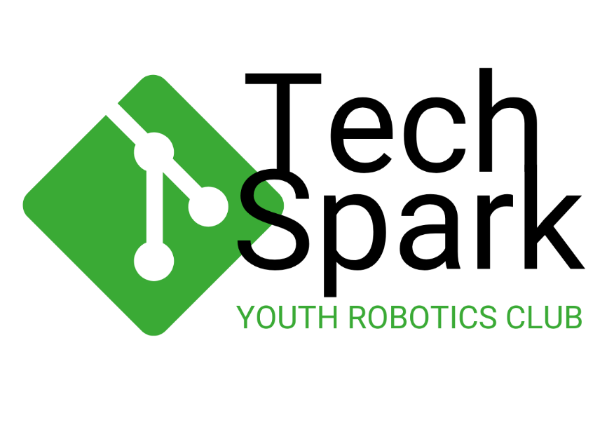

|  |  |
| --- | --- |
| Guest arrival | 14:30 to 15:00 |
| Welcoming  By Bjorn Wiedow- Founder of Robotschool | 15:00 to 15:15 |
| Project Background  By Cliff Olivier- Director of Tucsin | 15:15 to 15:30 |
| Konrad Adenauer Stiftung Remarks  By Mrs Natalie Russmann – Director of KAS Office Namibia & Angola | 15:30 to 15:45 |
| Certificate Handover  By Mrs Natalie Russmann – Director of KAS Office Namibia & Angola | 15:45 to 16:15 |
| Photos and Refreshments | 16:15 to 16:30 |

**Program for the TechSpark Certificate Handover 29th of November 2024**

Proudly Implemented by:

