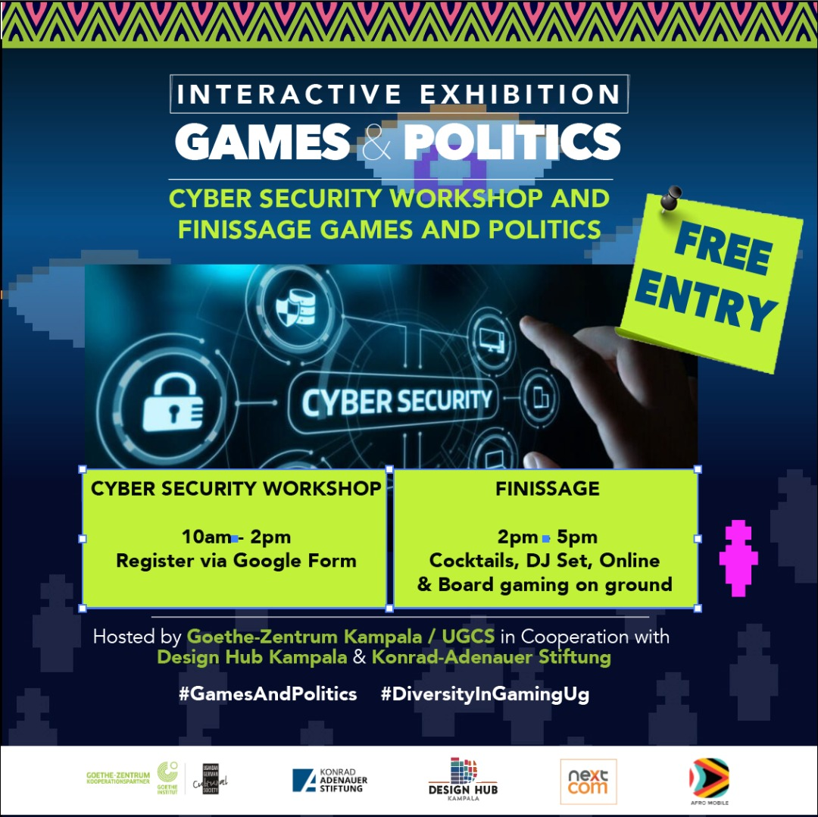

PROGRAMME
Saturday, 21st May
Time | Activities
9 – 10 AM | Arrival and Networking
10 – 2 PM | Cyber Security Workshop – Facilitated by Bastion Technologies
2 – 2:15 PM | Opening Remarks – Danze Edwin, Curator of the Games and Politics Exhibition  - Interactive Board Gaming Sessions
2:15 – 3 PM | Reflections on Civic Engagement and New Perspectives from the Gaming Exhibition  - Jean Kukunda, Director - Design Hub Kampala  - Anna Reismann, Country Director – KAS Uganda and South Sudan  - Christian Kettelhut, Director Goethe Zentrum Kampala
3 – 4 PM | Gaming/VR Exhibition
5 – 6 PM | Networking Cocktail, DJ Concert

