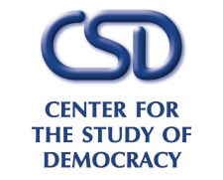

*Round Table*

**Energy Security Risks and**

**Energy Security Agenda in Southeast Europe**

26 November 2018

Sofia Hotel Balkan, Sredets Hall

|  |  |
| --- | --- |
| **10:30** | *Opening*  **Ognian Shentov,** Chairman, Center for the Study of Democracy  **Thorsten Geissler,** Director, Sofia Office, Konrad Adenauer Stiftung |
| **10:45** | *Taming the Beast: Are Diversification, Affordability and Sustainability Possible*  **Martin Vladimirov**, Energy Analyst, Center for the Study of Democracy  **Delyan Dobrev**, Chairman, Energy Committee, Bulgarian Parliament |
|  | *Unlocking the Natural Gas Market in Southeast Europe: the Gas Interconnector Greece–Bulgaria*  **Eric Rubin,** Ambassador of the United States to Bulgaria  **Teodora Georgieva,** Executive Officer, ICGB AD  **Ilian Vassilev,** Ambassador of Bulgaria to Russia (2000-2006) |
|  | *Discussion Buffet*  *Moderator:* **Ruslan Stefanov**, Director, Economic Program, Center for the Study of Democracy |
| **12:00** | *Buffet* |